 **---------------------------------------------------------------------**

**Learn Crypto currency by Vaibhav**

**---------------------------------------------------------------------**

**Business Flow of the Application.**

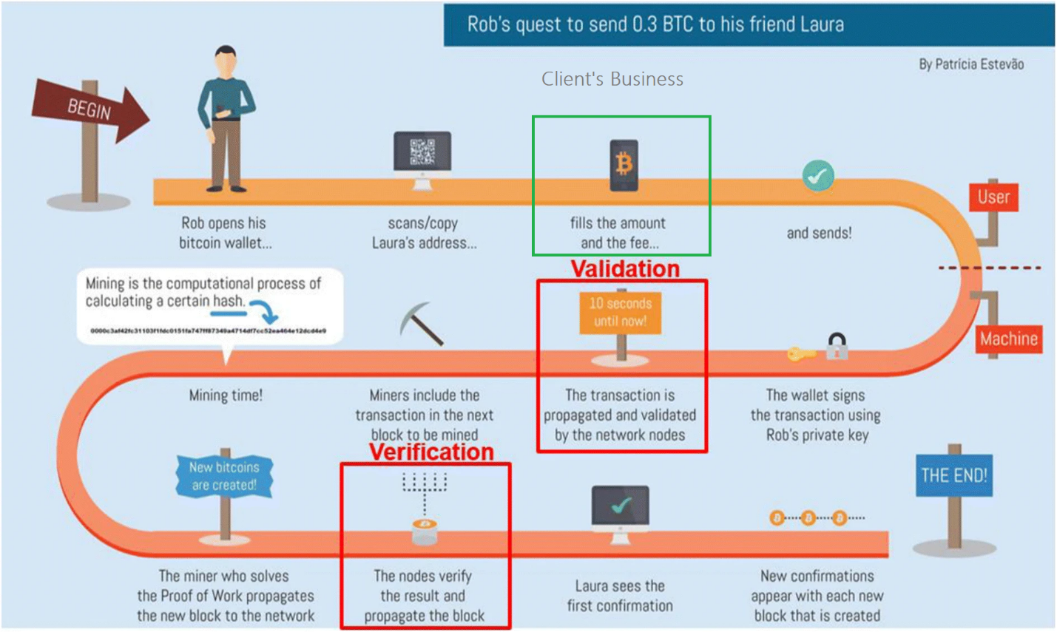

* Business Flow: When any Transaction Successful 🡪 Client charges **0.2 Maker Fee and 0.2** **Taker Fee** for Each transaction **(Crypto Currency Buy and Sell).**
* Client also charges few % (0.005 Percent) for Send any Crypto currency.

-----------------------------------------------------------------------------------------------------------------

1. What is **Crypto** currency?

Digital/Virtual currency in which **transactions** are verified and records maintained by a decentralized system. (**Block Chain**)

Using **Crypto currency** – One Can -🡪

* Buy
* Sell
* Send
* Receive.

-----------------------------------------------------------------------------------------------------------------

**In the Project I have worked on:**

1. Buy and Sell Module (Exchange Module)
2. FUNDS Module🡪 Send(**Withdraw**) and Receive(**Deposit**) Module (Transfer Module –Withdraw and Deposit)
3. Peer to Peer Module
4. Funds Module
5. Profile Module
6. Graph Module

----------------------------------------------------------------------------------------------------------------

1. **Buy Module**

Consider One Scenario 🡪

|  |  |  |
| --- | --- | --- |
| **BUY** | **Result** | **SELL** |
| 1 User 🡪 1 Bitcoin Purchase @1000 | No Match between Buyer and Seller 🡪 Order Opened 🡪 **Order Cancelled. Order Not Executed** | 1 User 🡪 1 Bitcoin Sell @1200 |
| 1 User 🡪 1 Bitcoin Purchase  @1000 | As Buying Price is more🡪 The will instantly **Executed**.   * Order Complete | 1 User 🡪 1 Bitcoin Sell  @900 |
| 1 User 🡪 1 Bitcoin Purchase  @1000 | Buy Price and Sell Match 🡪 Order Complete and Executed. | 1 User 🡪 1 Bitcoin Sell  @1000 |
| 1 User 🡪 1 Bitcoin Purchase  @1000  Buyer give 🡪 1000  Later WazirX return 500 RS | Only 0.5 Bitcoin buy by the Buyer. And Rest Amount is credited to Wallet. Seller Sell the 0.5 Bitcoin.  Order 🡪 Partially Executed. | 1 User 🡪 0.5 Bitcoin Sell  @1000 for 1 Bitcoin.  Seller will get 🡪 500 |
| 1 User 🡪 0.5 Bitcoin Purchase @1000 per Bitcoin  Buyer will pay 🡪 500 Rs | Only 0.5 BTC sold to Buyer.  Order 🡪 Partially Executed. | 1 User 🡪 1 Bitcoin Sell  WazirX give 500RS(0.5 BTC Sold) and Will return remaining **0.5 BTC** |

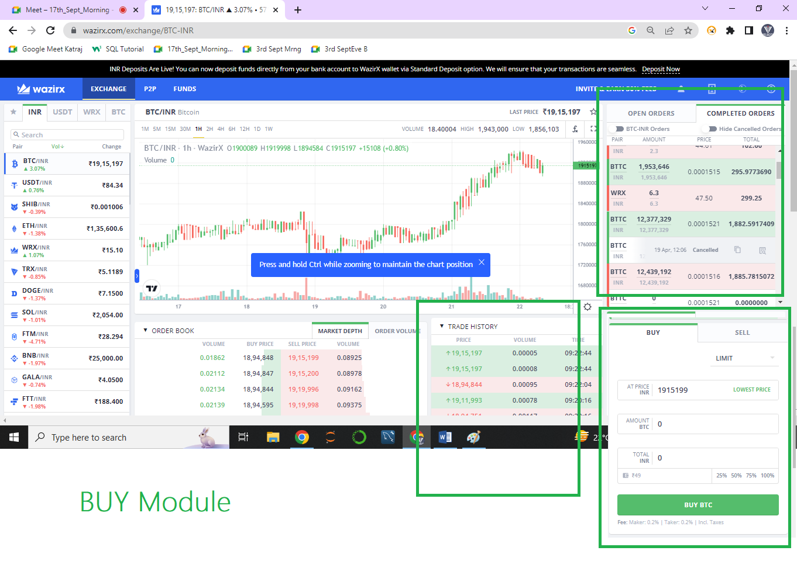

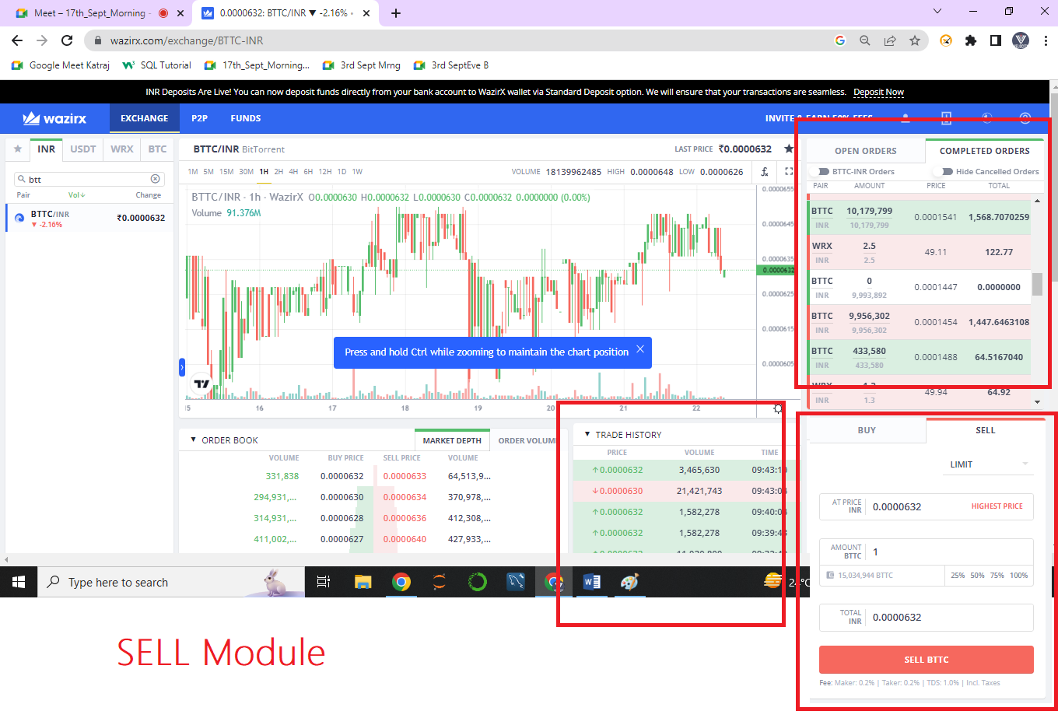When User placed one Buy Order 🡪 **Buy** Bitcoin at **RS 1000** order Placed and **Seller** Prices Ranges from Min **5000-5500**Max Rs Varies.

1. Placed Buy Order 🡪 Displayed in “**Open Order**”. 🡪 After 24 Hours if order not executed 🡪 **Completed and Cancelled.**
2. Placed Buy Order 🡪 Displayed in “**Open Order**” 🡪 In 24 Hours duration if order executed 🡪 **Completed and Executed.**

If User want to Buy any Crypto currency 🡪 INDIAN RS must be available in your Wallet.

If User want to Sell any Crypto currency 🡪 Selected Crypto Currency must be available in your Wallet.

**Placed Order. 🡪 Open Orders.**

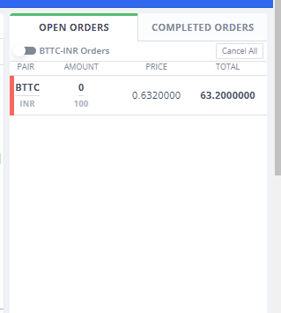

---------------------------------------------------------------------------------------------------------------------

**FUNDS Module**

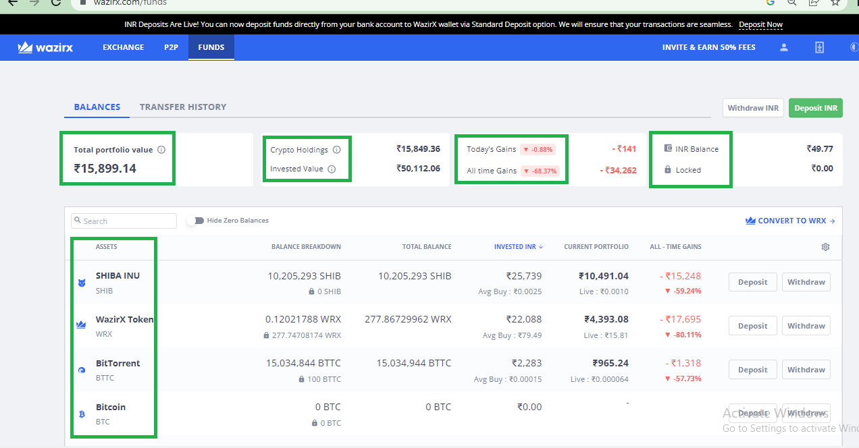

ALL TIME GAIN = Current Portfolio – All Time Investment

Current Portfolio = Current Coin Price * Total Balance (**Coin**)

Investment INR = Total No of Time you have purchased the Currency.

Crypto Holding = Addition of all the Coin’s Current Portfolio Values.

Invested Value = Addition of the Invested INR for ALL Coin.

Total Portfolio Value = Addition of All Current portfolio Value.

**Transfer History.**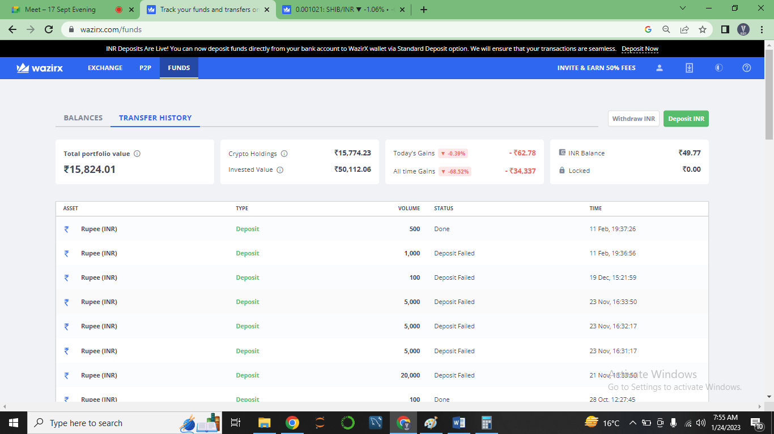

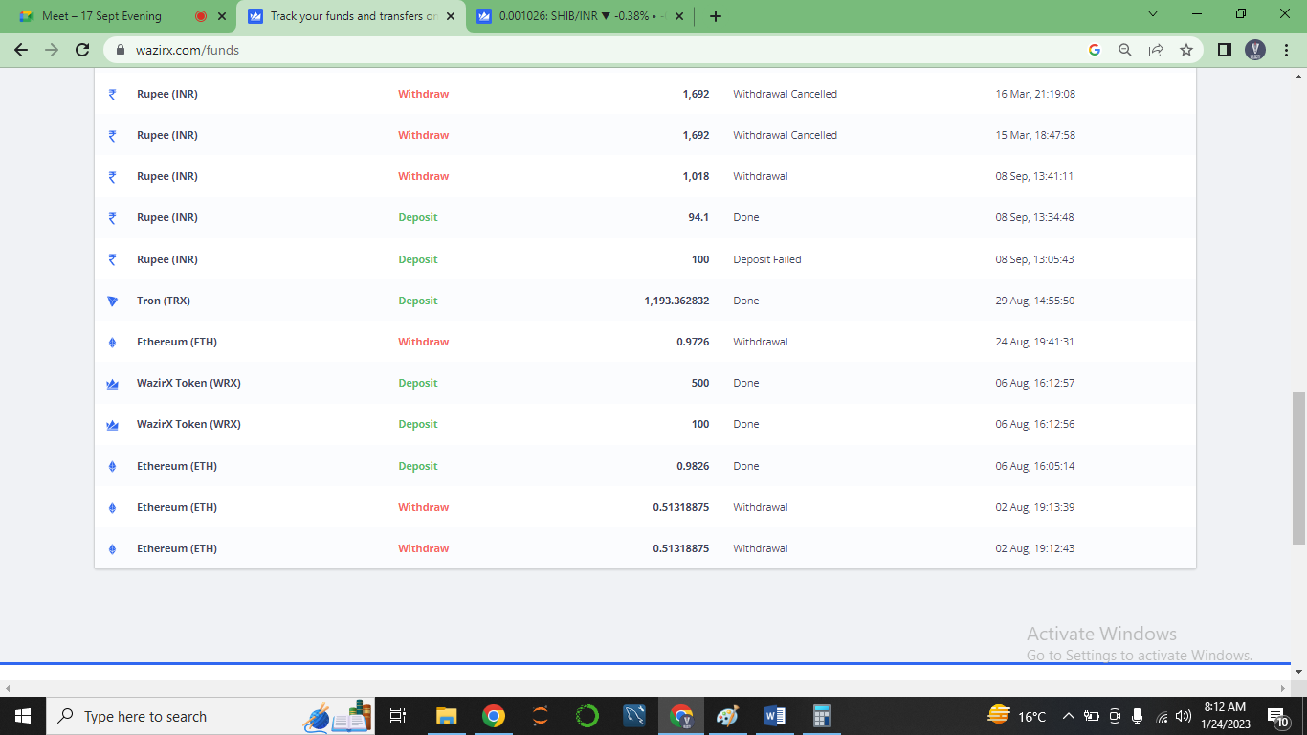

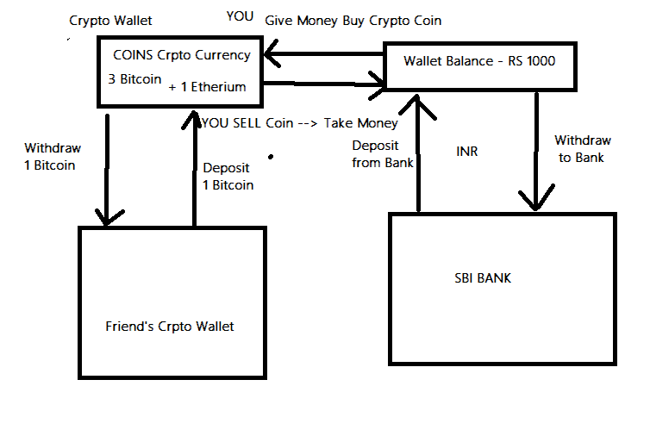

**WITHDRAWAL and DEPOSIT FOR INR**

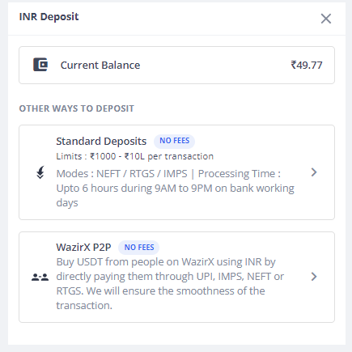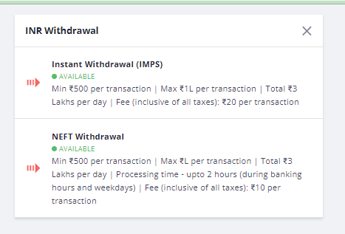

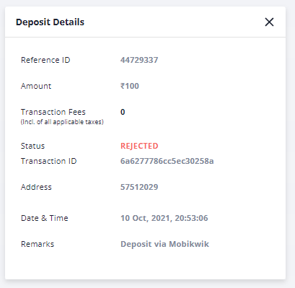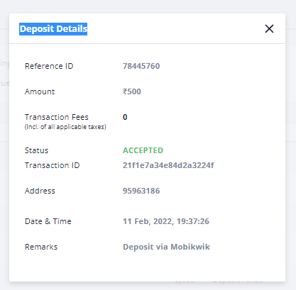

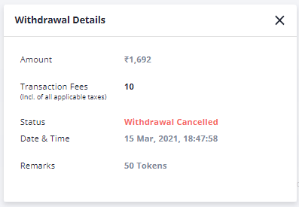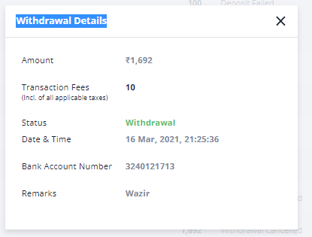

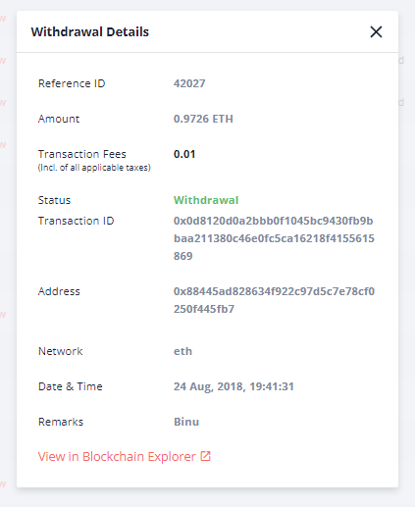

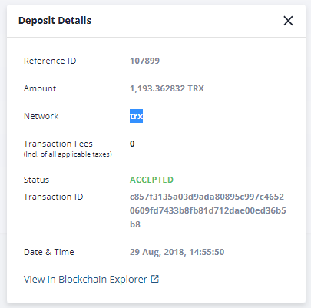

[**https://etherscan.io/tx/0x0d8120d0a2bbb0f1045bc9430fb9bbaa211380c46e0fc5ca16218f4155615869**](https://etherscan.io/tx/0x0d8120d0a2bbb0f1045bc9430fb9bbaa211380c46e0fc5ca16218f4155615869)

[**https://tronscan.org/#/transaction/c857f3135a03d9ada80895c997c46520609fd7433b8fb81d712dae00ed36b5b8**](https://tronscan.org/#/transaction/c857f3135a03d9ada80895c997c46520609fd7433b8fb81d712dae00ed36b5b8)

**---------------------------------------------------------------------------------------------------------------------------**